s

Data set provided by Project Team

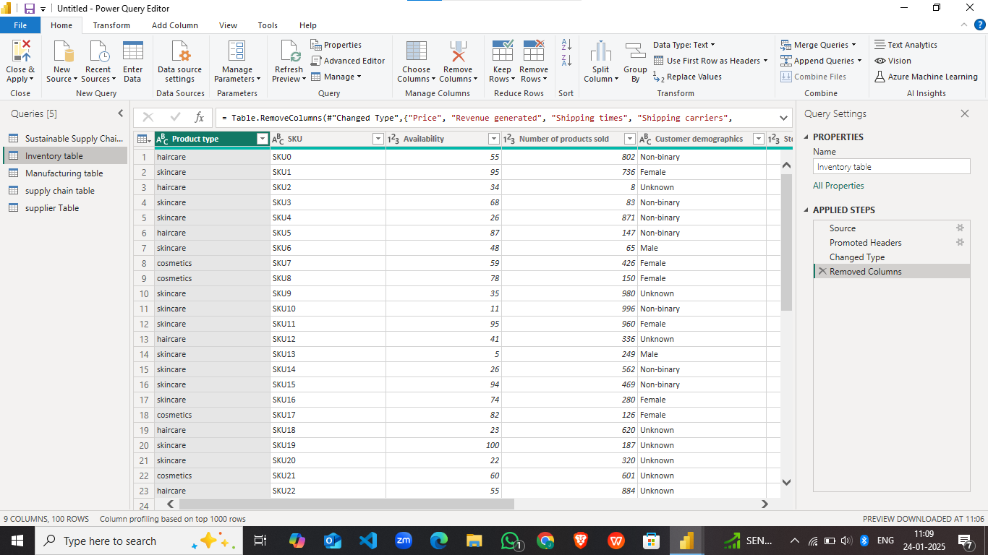

The above data is cleaned for future analysis and named as Inventory Table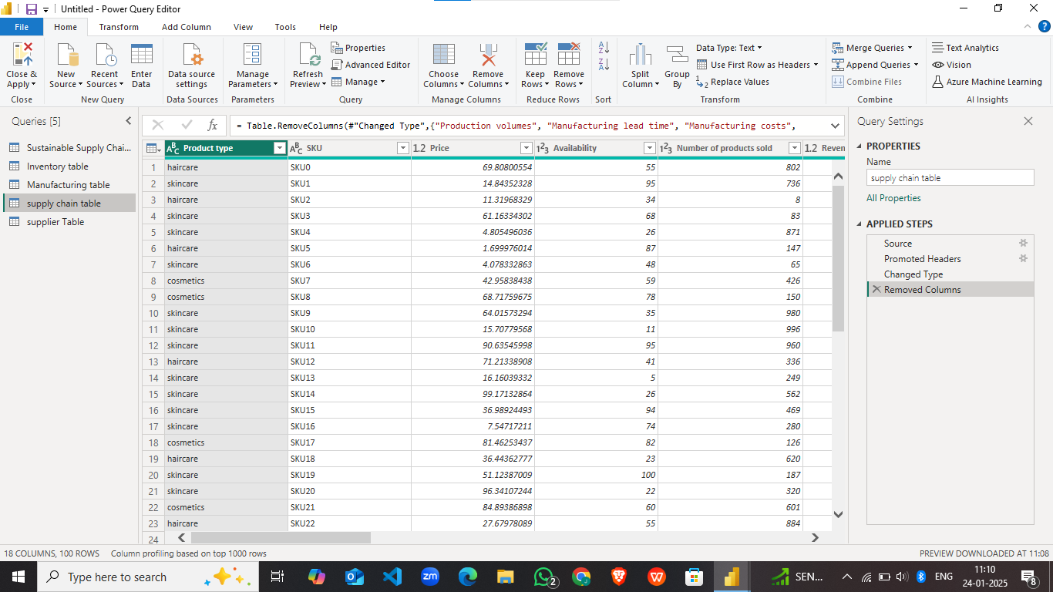

The above data is cleaned for future analysis and named as Supply chain table

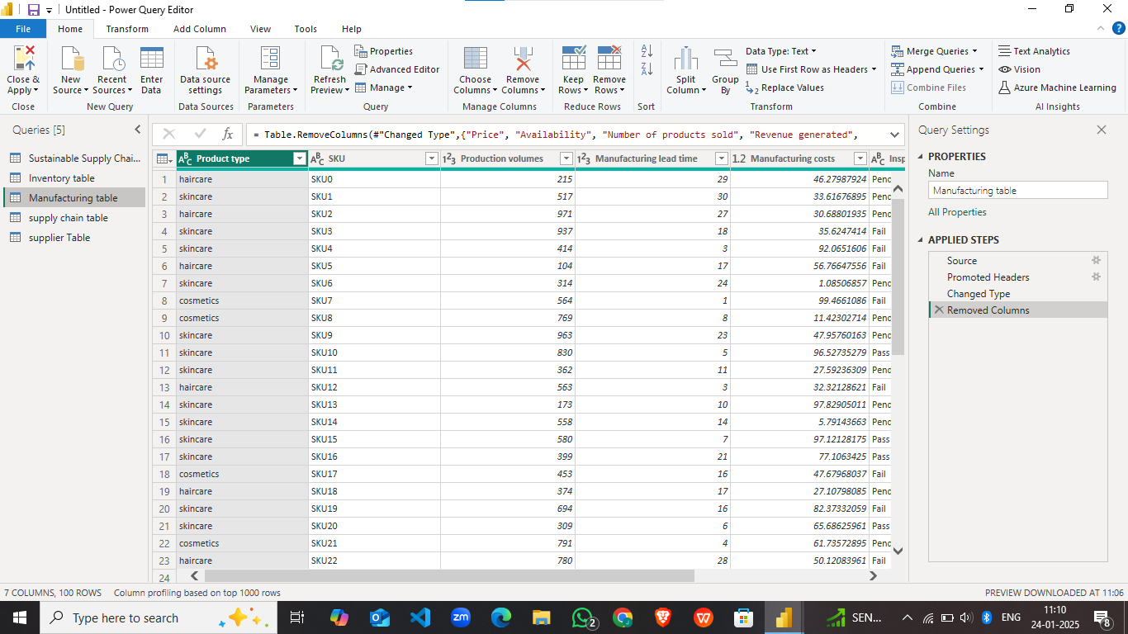

The above data is cleaned for future analysis and named as Manufacturing table

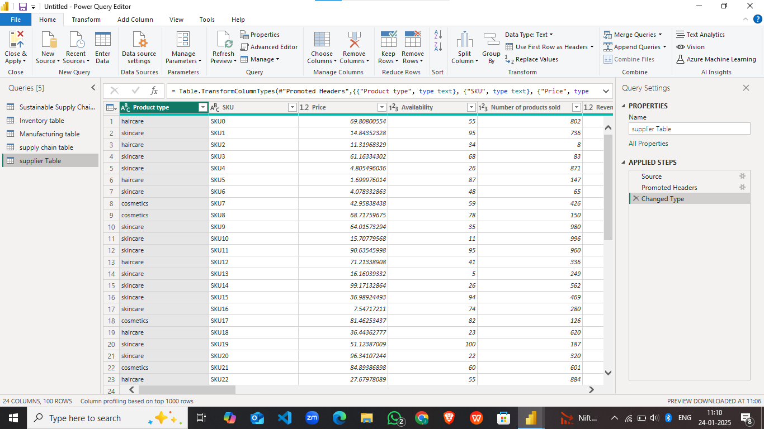

The above data is cleaned for future analysis and named as Supplier Table